**ADAILY ONLINE ACTIVITIES SUMMARY**

|  |  |  |  |  |  |  |  |
| --- | --- | --- | --- | --- | --- | --- | --- |
| **Date:** | **20/06/2020** | | | | **Name:** | **Anusha. K** | |
| **Sem & Sec** | **4th SEM 'A' Section** | | | | **USN:** | **4AL18CS009** | |
| **Online Test Summary** | | | | | | | |
| **Subject** | | **Data communication** | | | | | |
| **Max. Marks** | | **30** | | **Score** | | **25** | |
| **Certification Course Summary** | | | | | | | |
| **Course** | **Introduction to neural networks and deep learning** | | | | | | |
| **Certificate Provider** | | | **greatlearning academy** | **Duration** | | | **9.5 hours** |
| **Coding Challenges** | | | | | | | |
| **Problem statement 01:Write a C Program to rotate an array by K positions.**  **Problem statement 02: Program that compares counting words in files using an ArrayList and a Map.**  **Problem statement 03: Write a C Program to rotate an array by K positions.**  **Problem statement 04:Write a C Program to rotate a Matrix by 90 Degree in Clockwise or Anticlockwise Direction. Implement (Both the rotations in single program using switch case statement).** | | | | | | | |
| **Status: completed** | | | | | | | |
| **Uploaded the report in Github** | | | | **yes** | | | |
| **If yes Repository name** | | | | [**https://github.com/anusha20219/Lockdown-coding**](https://github.com/anusha20219/Lockdown-coding) | | | |
| **Uploaded the report in slack** | | | | **yes** | | | |

ONLINE TEST DETAILS: Data communication test was conducted from 2 pm to 2:30pm. There were 30 questions and time allotted was 30 mins. The questions were mcq type.

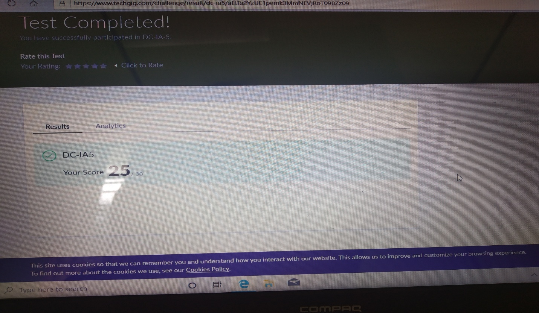

Certification course details: Today I started with introduction to neural networks and deep learning certification course in which I studied the topics introduction to tensor flow and introduction to keras.

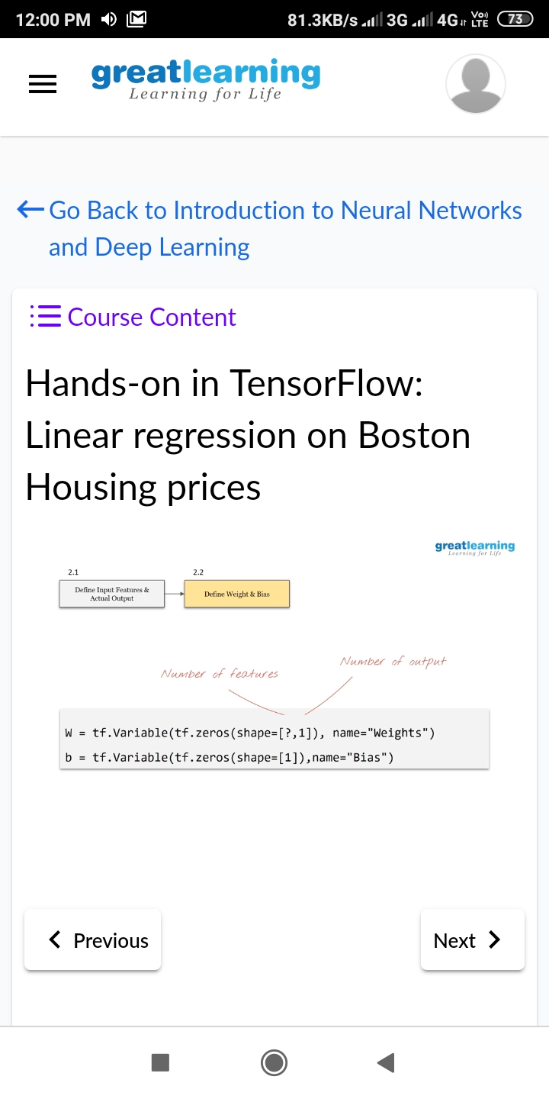

Coding challenge details:

Problem statement 01: Write a C Program to rotate an array by K positions.

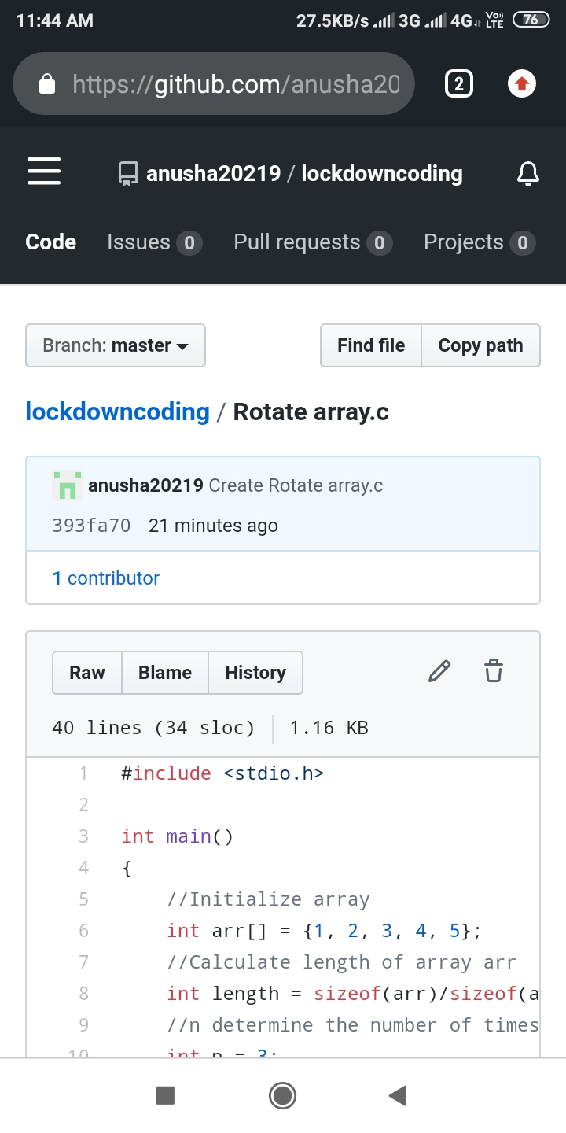

Problem statement 02: Program that compares counting words in files using an ArrayList and a Map.

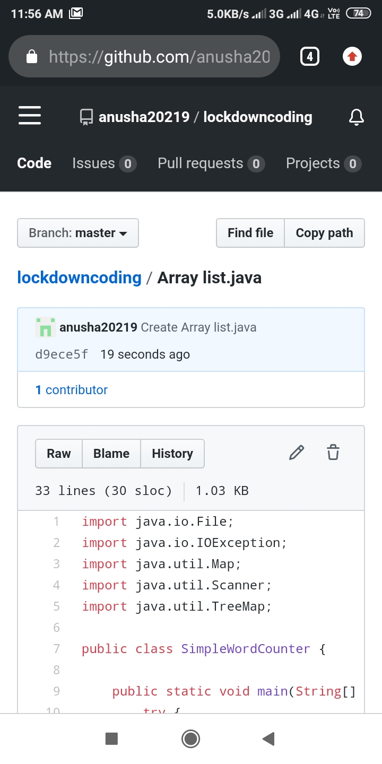

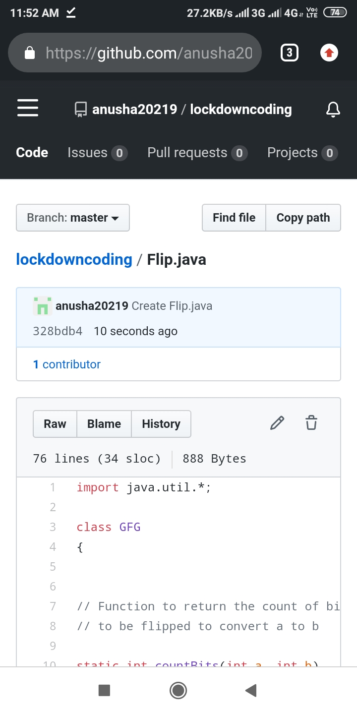Problem statement 03: Write a Java program to count number of bits to be flipped to convert A to B.

Problem statement 04:Write a C Program to rotate a Matrix by 90 Degree in Clockwise or Anticlockwise Direction. Implement (Both the rotations in single program using switch case statement).

